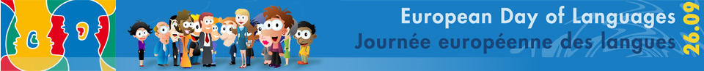
Name…………………………………………
Breakfast around Europe
Can you guess which European country these breakfast items come from? Use the options at the bottom to help you and write your answers in the boxes under each picture.
We’ve given you a description of the harder items!
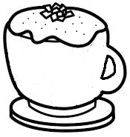 | 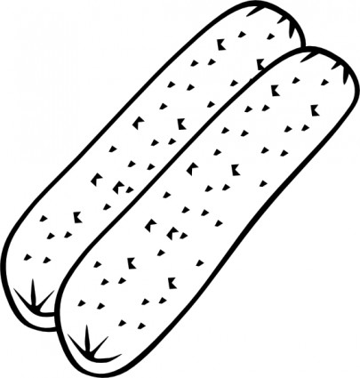 | 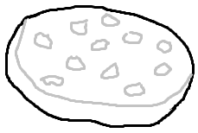 | 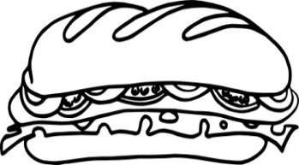
Cappuccino | Wurst | Draniki  (Potato Pancake) | Kanapka  (Meat or cheese filled sandwich)
1. Italy | 2. Germany | 3. Belarus | 4. Poland
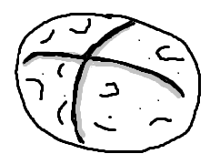 | 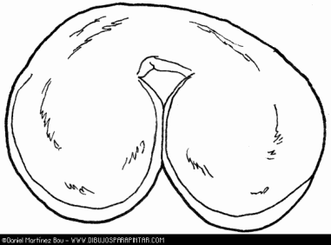 | 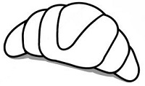 | 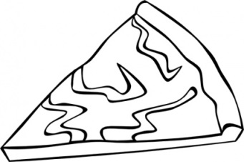
Wheaten Farl | Palmera Dulce  (Flaky pastry rolled bun) | Croissant | Burek  (Pastry stuffed with meat or cheese)
5. Ireland | 6. Spain | 7. France | 8. Croatia
France Italy Germany Poland
Croatia Ireland Belarus Spain

